Glenrothes & District Foodbank
Community Project
Club 200 Bank Mandate

When completed please this form to the Foodbank Manager.
Name of Bank
Address
Post Code

Please pay: Clydesdale Bank, 5 Falkland Gate, Glenrothes, KY7 5NS
Sort Code: 82-68-31 Account Number: 00106560

For the credit of: Glenrothes & District Community Foodbank Project, Caledonia House, Pentland Park, Saltire Centre, Glenrothes, Fife, KY6 2AQ

The sum of (in words) Pounds [£ ]

To be paid on (day) (month) (year)
and thereafter every month until further notice and debit my account accordingly.

Name of account holder to be debited
Account number
Sort code
Signed
Date
Full Address
Post Code

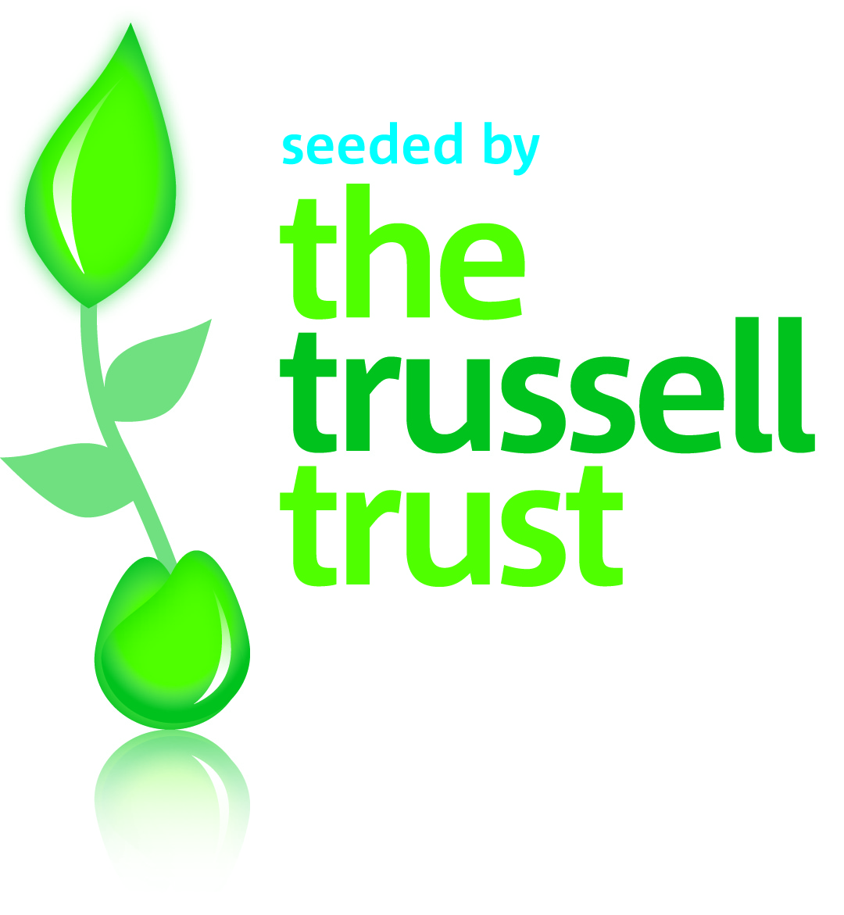

Scottish Charity Number: SC045445

