Glenrothes & District Foodbank  Community Project  Gift Aid Declaration | 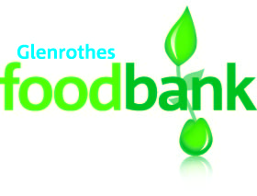

Boost your donation by 25p of Gift Aid for every £1 you donate
Gift aid is reclaimed by the charity from the tax you pay for the current tax year. Your address is needed to identify you as a current UK taxpayer.

I want to Gift Aid all donations I make from the date of this declaration and have made in the past 4 years to:

Name of Charity: Glenrothes & District Foodbank Community Project [SC045445]

I am a UK taxpayer and understand that if I pay less Income Tax and/or Capital Gains Tax than the amount of Gift Aid claimed on all my donations in that tax year it is my responsibility to pay any difference.

My Details

Title First name or initial(s)

Surname:

Full home address:

Postcode Date

Please notify the Foodbank if you:
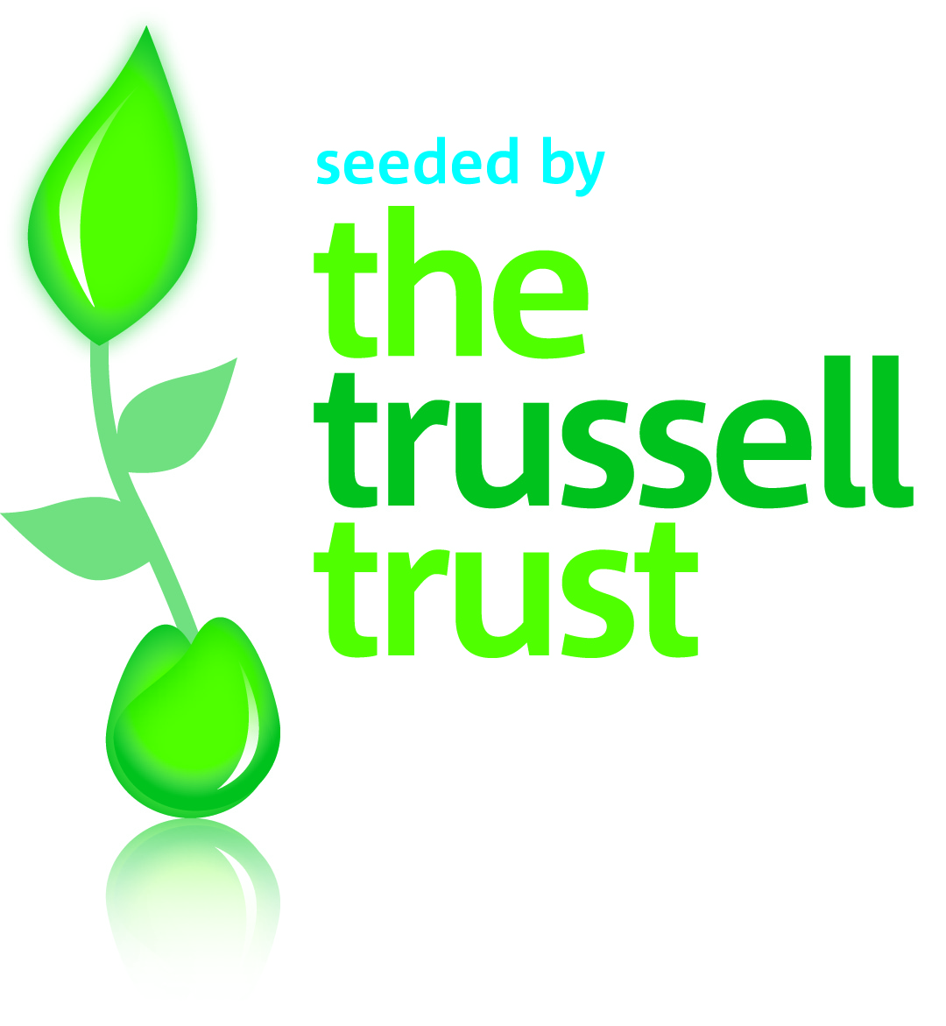
- want to cancel this declaration
- change your name or home address
- no longer pay sufficient tax on your income and/or capital gains

I confirm that I have paid or will pay an annual amount of Income Tax and/or Capital Gains Tax that is at least to the amount of tax that all the charities which I support will reclaim on my gifts. I understand that other taxes such as VAT and Council Tax do not qualify.

Scottish Charity Number: SC045445

